Quintiles

**Forsyth County Trend of quintile incomes**

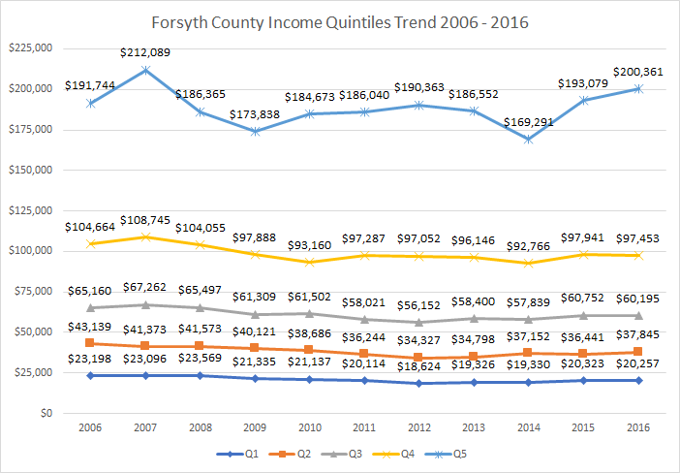

* Households in all quintiles are making less (Q2 and Q3) or statistically the same amount of money as they were in 2006 (Q1, Q4, Q5).
* 2007 reflects peak household incomes for Q3, Q4, and Q5 followed by significant losses by 2009 (e.g., Q5/the 95 percentile dropped from $212K in 2007 to a low of $174K in 2009),. As of 2015, Q5 regained its 2007 height. Q4 has not regained its 2007 height, but it is now comparable to its 2006 height. Q3 has not rebounded, i.e., income is still significantly lower than it was in 2006 and 2007.
* Household incomes in Q1 & Q2 did not see the significant drops other quintiles saw between 2007 and 2009, Q1 & Q2 started taking significant hits around 2011 and 2012. As of 2015 Q1 has regained its height of 2006 & 2007, i.e., incomes are comparable to those levels. For Q2, in 2016 household incomes remains significantly lower than the 2006 household income.

**Peer comparisons of Quintile Incomes**

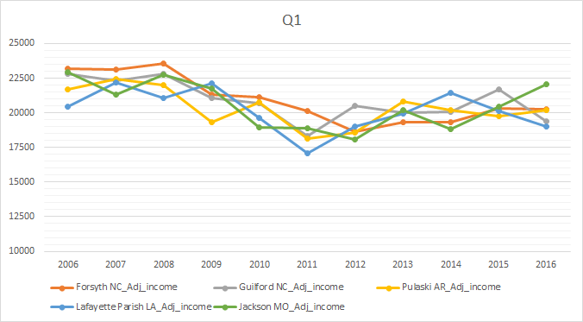

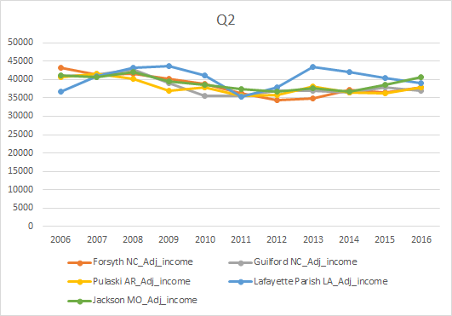

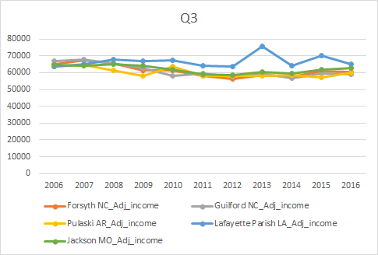

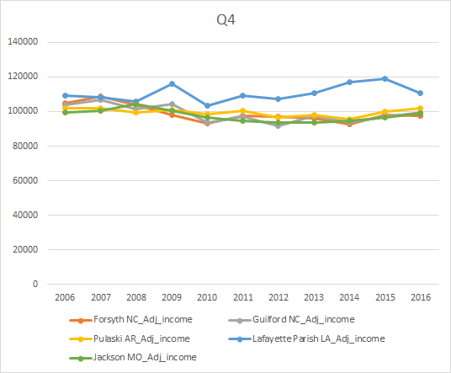

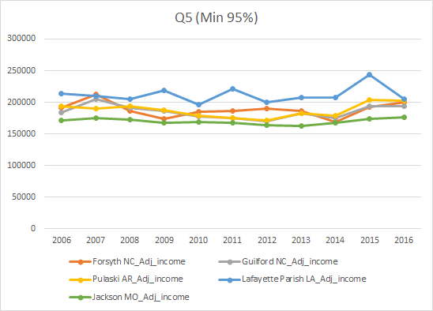

Not a lot to say about peer comparisons. Forsyth is significantly different from Lafayette in all qunitles except Q1 in several years. Most differences are observed in Q5 with Lafayette, Jackson and Pulaski (only in 2007). Except for Lafayette in all but Q1 and Jackson in Q5, peers over time were statistically similar, i.e., followed the same trend.

**Trend Age 18-44**

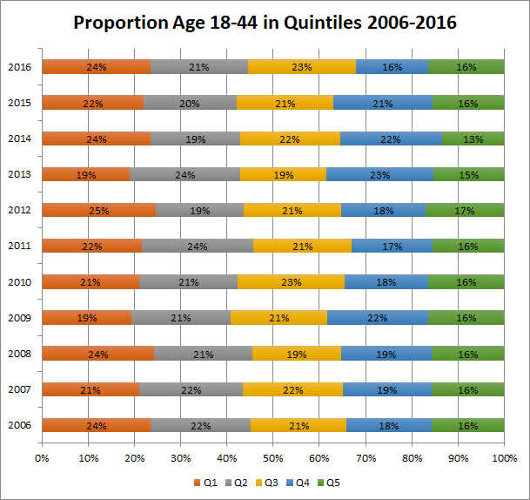

* Very little change in quintile proportions over time.
* That said, Q4 saw significant drop in 2016 from 2013, 14 and 15.
* 2006 and 2016 statistically the same proportion of households in each quintile.

**Trend Age 45-64**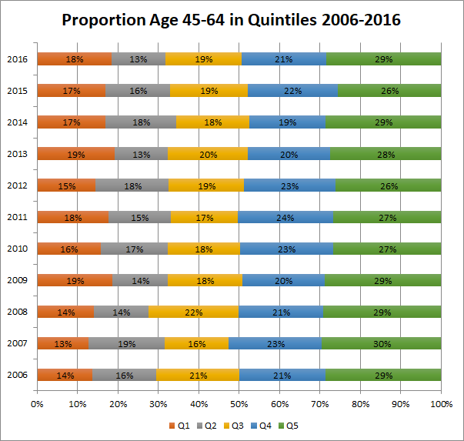

* 2006 and 2016 not statistically significantly different

**Trend Age 65+**

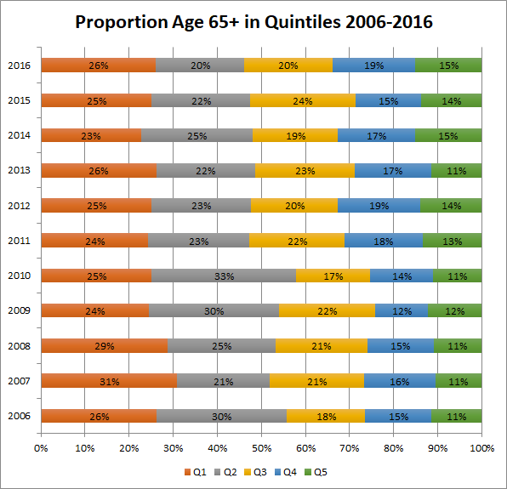

* Q2 is most volatile - 2006 to 2007 statistically significant drop the difference of which is mostly spread into Q1 & Q3. Creeps back up and drops again significantly between 2010 & 2011 in which the difference is made up for in the higher Quintiles, especially Q4. After that Q2 proportion remains steady
* Trend appears to be neutral or positive. Q1 remains steady over time (exact same 2006 and 2016), but Q2 dropped significantly bw 2006 and 2016 and difference was spread among top 3 Quintiles

**Age group comparison**

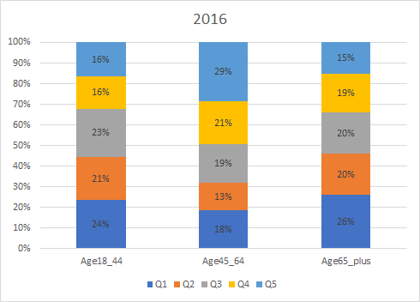

* Those age 45-64 have the highest population/proportion of households in the upper quintiles (Q3, Q4, Q5), approximately 15% more than the others (which makes sense as this is the age group in which people are generally making the highest salaries during their lifetime)
* All quintiles are statistically similar for those aged 18-44 and 65+

**Trend Blacks**

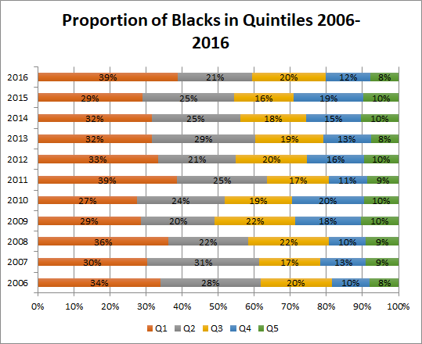

* A significant increase in the Q1 proportion of black households occurred between 2010 and 2011 and was matched with a similar decrease in Q4 black households.
* From 2011 to 2015 the proportion of black households in Q1 dropped significantly while Q4 proportion gained significantly (but then the bottom dropped out).
* 2016 once again saw a significant increase in the proportion of blacks households in Q1 combined with a significant decrease in the proportion in Q4.
* Overall, in comparing 2006 & 2016, there were no statistically significant changes observed in the proportions
* Data Warning - even the difference in Q2 between 2006 and 2016 (28% to 21%) was not statistically significant at the 95% confidence level (though it would have been at the 90%, z-score 1.78).

**Trend Hispanics**

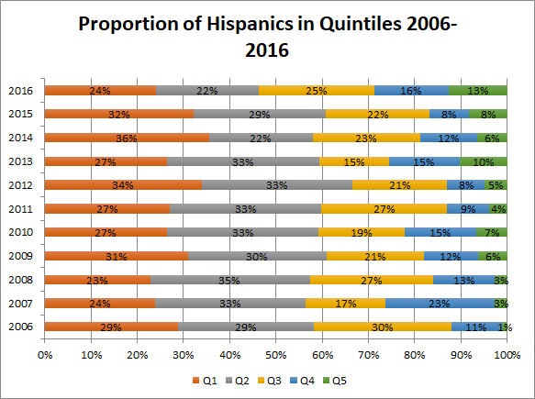

* There is a general trend towards a greater proportion of hispanics in Q5 (and can we say Q4 Elizabeth if there is no statistical significance between Q4 in 2016 and any of the other years?) (CVs are over 30, but not hugely - 2013-2016 the Q5 CV = 38).
* As of 2016, the Hispanic population is the most evenly spread among quintiles compared to the other races measured. That is to say that none of the quintiles are statistically significant from each other. (Note: The CVs for 2016 are fairly good, all between 12-30, except for Q5 which is at 38 - still not horrific).
* Data Warning: Though there appear to be considerable year over year fluctuations in Q1, Q2, Q3 and Q4, due to greater SEs, none of them are statistically significant (and almost all CVs for Q1, Q2 and Q3 are between 12-30, Q4 CVs are over 30). In other words, there is not a lot you can reliably say about the YOY comparison of quintiles.

**Trend Whites**

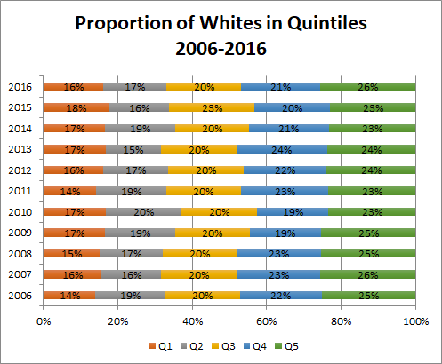

* Main Point: Proportion of whites overtime has remained consistent. Very little significant changes in proportions. 2016 is not significantly different from any of the previous years.

**Race groups comparisons**

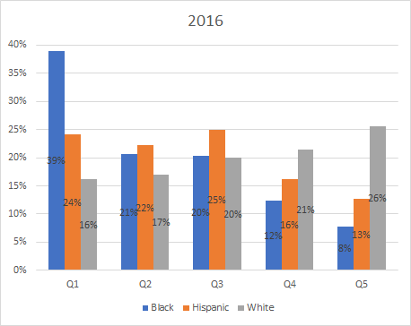

*I realize this chart is not really the way to display this data, but I like how it visually calls out the difference in Q1/Blacks and Q5/Whites.*

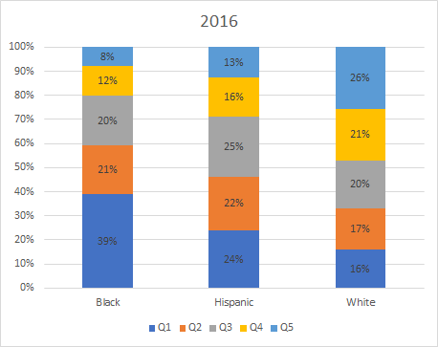

* There is a significantly higher proportion of black households than hispanic or white households in Q1.
* The proportion of Black households are also significantly less than white households in Q4 and Q5.
* The proportion of Hispanic households are statistically similar to the number of white (and black) households in Q4, however, they are not the same as white households in Q5.